DeepAR Condo Price Forecasting

Regression would typically be used for Condo price forecasting, but I was interested in trying to capture multiple layers of connected information: neighbourhood, building quality (both of construction and building maintenance / management), seasonality and turnover.
Unfortunately, I was not able to set up the information for DeepAR in a way that was able to connect these types of relationship.
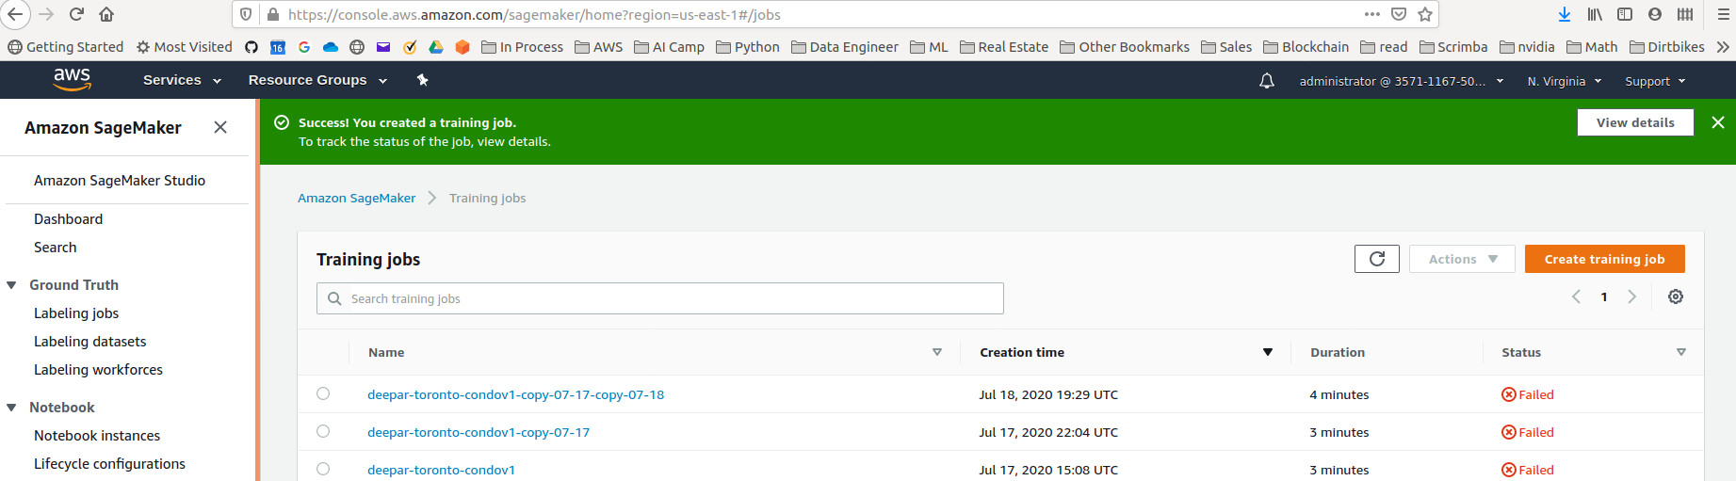
The training jobs failed because I didnt fully understand the requirements for the ‘cat’ and ‘dynamic feat’ fields.
It’s unfortunate that I spent a week preparing the data for an algorithm that I didn’t fully understand. However, I have learned a lot about DeepAR; I also learned that diving into a project without properly understanding the algorithm is a mistake.
I will continue going through the Forecasting tools in AWS to find the right algorithm.

